Teachers, coordinator, organisation summerschool 2016 Zwolle

Olivier Glas (HAN University)

At HAN University I teach research, theory, methodic skills and therapeutic skills. Besides my teaching, I am doing a research on expanding the sustainability of preventive movement-interventions for people with severe mental illness.

In a former part of my career I did psychomotor therapy with people with addiction, anxiety disorders and forensic psychiatric issues.

My personal fascination with psychomotor therapy is integrating a certain method or type of movement with theory (pathology and treatment) and therapeutic skills.

I’m looking forward to cooperate this summer in Zwolle, with students, Cristina and other teachers!
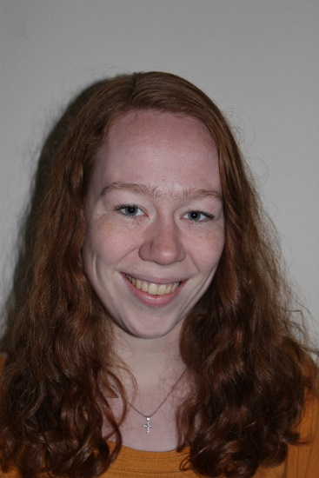 | My name is Nathalie and together with Katinka, I'll organise the summer school in Zwolle. I am 23 years old, and I'm a graduated psychomotor therapist since july 2016. Last IP in Zürich and last summer school in Paris, I was a participant myself and I stayed in Paris to do an Erasmus semester. Besides English, I speak barely fluently French. I love to do gymnastics, acrobatics and running. In my spare time I meet up with friends in lovely Nijmegen.  I’m really looking forward meeting you all this summer & until then you will regularly receive emails from us !
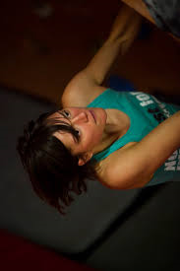 | My name is Katinka van Sprang and I´m one of the Dutch students helping Cor organize this year Summer School. I´m 25 years old and will finish my studies in May. Next to my, almost, bachelor PMT, I finished the bachelor Health Sciences (specialisation mental health) in Maastricht (the entire south of Holland and, for me, the most beautiful city of our country).  In my spare time I try to go to the mountains (Switzerland, Austria, France, Italy) as often as possible to climb, hike, run, bike and ski. But since this isn’t always possible I try to stay fit by running and visiting the indoor climbing gym a couple of times a week.  I’m really looking forward meeting you all this summer & until then you will regularly receive emails from us !
My name is Fred Dijk and teacher psychomotor therapy for 10 years now. I worked as a therapist for about 12 years with clients with eating disorders and violent offenders. Since 5 years I am trainer Mindfulness. I’m very grateful to work with young professionals as you are.
I like to play guitar & sing songs of Tom Waits and grow my own vegetables (well nature does, I just water them in time).
Looking forward meeting you all in Zwolle!
Fred Dijk

Hi! I’m Cristina Espadinha a teacher from Portugal - FMH.

I’m a very lazy person, so I’m always searching for easier and better ways to do things, thus I always searching for gadgets and technologies to do the work for me.

I’m an optimist and always try to see the bright side of everything.

These two characteristics make me a professional that joins psychomotor therapy with technologies and always searching for new methodologies to explore.

So I’m going to Zwolle with two goals:

-to appreciate every minute and
- to learn from all of you, students, teachers and organization.
sylvie Bébin, psychomotor therapist

Hello my name is Sylvie Bébin, psychomotor therapist since 1985! Yes it’s possible and I get such energy yet that I surprise myself sometimes!!

I began working in daycare nurseries then in different institutes for children with behaviour disorders, learning disorders. For 7 years, I have worked in a liberal cabinet and since 2009 with autistic children. Furthermore, I teach sensory motricity, teaching skills and psychomotricity for autistics to students and childcare professionals.

For the early beginning of my career, I have been found a great interest to sensory integration and almost to SPD (sensory processing disorder); I turned my research toward this topic. And I’ve found a lot of answers on the children’s development.
I practice theatre, body percussions that I use in my work.

In Pair with Fred Dijk in Zwolle for the next summer school, I look forward meeting you and spending a week of work and fun.
 | My name is Dorte Wahlberg Feil. I am 47 years old. I was educated as an Psycomotor Therapist 17 years ago. I have been working with all kinds of groups since, especially mothers during pregnancy, afterbirth but also children and grownups. Now I am a teacher at one of the two Danish Psycomotricity schools in Denmark, VIA in Randers. I like to do meditation but also to be on the run. so I feel lucky to give lessons in movement and training. I look forward seeing everyone I September.
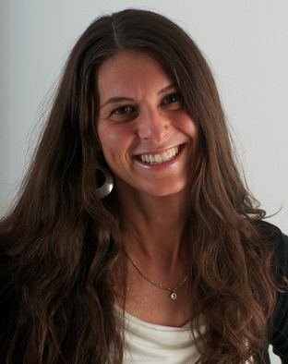 | Michèle Schumacher  Zurich, Switzerland  Trained as an organizational psychologist and work experience in the learning development field.  Further education as a psychomotrician and 6 years of work experience with children aged 6-11 years. Therapeutical work, prevention in schools and coaching of parents and teachers.  Focus is on body development, self-concept and graphomotoric skills in a movement inducing setting.  Active in the Swiss Psychomotrician Association and the European Forum of Psychomotricity.  Personal hobbies: Contact improvisation and couple dance

